Mobile Programming Course Introduction

Mobile programming course covers iOS programming, Android programming and HTML5 programming for mobile devices.

A. iOS programming
What is iOS?
iOS is the operating system that runs on iPhone, iPod touch, and iPad devices. This operating system manages the device hardware and provides the technologies required to implement native applications. The operating system also ships with various system applications, such as Phone, Mail, and Safari, that provide standard system services to the user.

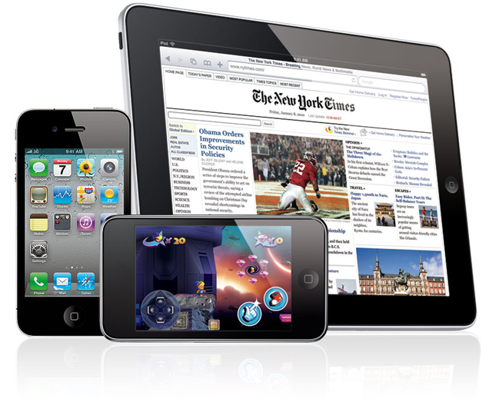
The iOS platform was built using the knowledge that went into the creation of Mac OS X, and many of the tools and technologies used for development on the platform have their roots in Mac OS X as well. Despite its similarities to Mac OS X, iOS does not require experience developing Mac OS X applications. The iOS Software Development Kit (SDK) provides everything you need to get started creating iOS applications.
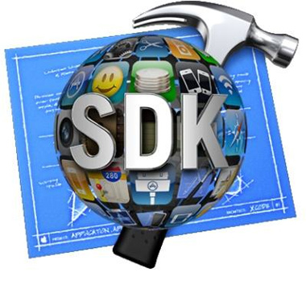
Apple also provides iPhone App Store, where there are more than 500,000 apps on that for download actually. Many apps are even free. Developers can register for a developer account, develop own apps and submit to App Store for distribution to million of Apple users to discover (free or paid, with or without integrating to advertising).
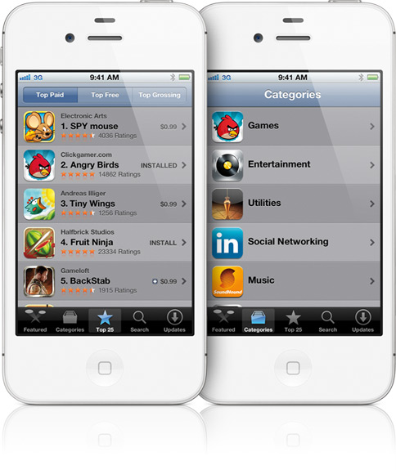

B. Android programming
What is Android?
AndroidTM delivers a complete set of software for mobile devices: an operating system, middleware and key mobile applications.
Android:
- Open
- All application and Created equal
- Breaking down application boundaries
- Fast & easy application development

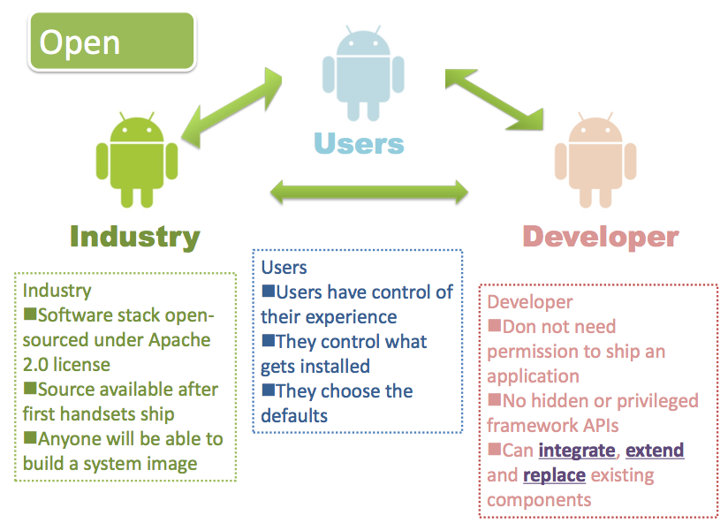

Sample show cases for Android apps:
Sodoku game:


3D models:
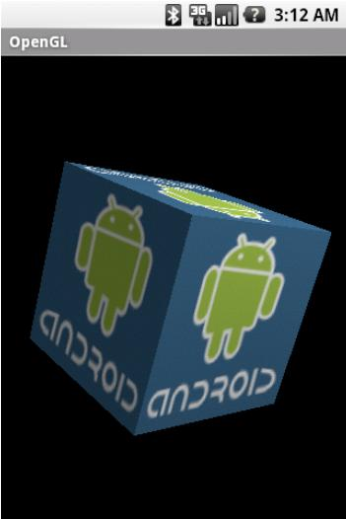
The same as Apple, there is Android market place where users can download apps as well as developer can upload own app for free or for sale.

C. HTML5 programming
What is HTML5?
HTML5 is a markup language for structuring and presenting content for the World Wide Web. Its core aims have been to improve the language with support for the latest multimedia while keeping it easily readable by humans and consistently understood by computers and devices. They allow web designers and developers to create advanced graphics, typography, animations, and transitions.

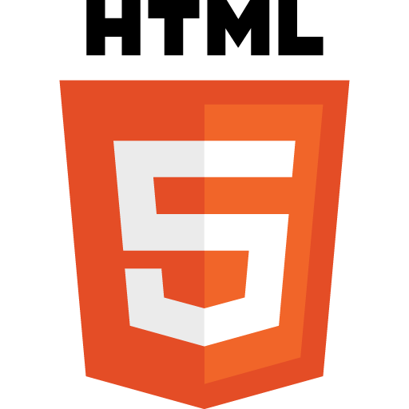
HTML5 programming for mobile devices is in fast increasing trend recently. Developers can do programming HTML5 for mobile using various SDK (free or paid).

Mobile programming course is designed with objectives for student to:
- understand basic knowledge of iOS programming for iPhone & iPad
- get some experienced with new programming language Objective-C
- get some experienced with all common controls of iOS
- get some experienced with debuging in iOS programming
- understand basic knowledge of Android programming which help student can self study further more easily
- understanding basic knowledge of HTML5 programming
- get some experienced with developing Hybrid mobile application using HTML5

